

MovLog

Group 6

Names : Geraldi Muhammad Yushar

Tjokorda Raka Wisnu Wardhana

Class : 4SC1

CEP CCIT

FAKULTAS TEKNIK UNIVERSITAS INDONESIA

2019



**Developed By**

1. **Geraldi Muhammad Yushar**
2. **Tjokorda Raka Wisnu Wardhana**

**PROJECT ON**

*MovLog*

Batch Code : 4SC1

Start Date : May 31, 2019

End Date : June 19, 2019

Name of Faculty : Indah Ayu Yuliani, ST, MM

Name of Developer :

1. Geraldi Muhammad Yushar
2. Tjokorda Raka Wisnu Wardhana

Date of Submission : June 20, 2019

**MovLog**



**CERTIFICATE**

This is to certify that this report titled “MovLog” embodies the original work done by Geraldi Muhammad Yushar and Tjokorda Raka Wisnu Wardhana. Project in partial fulfillment of their course requirement at NIIT.

Coordinator :

Indah Ayu Yuliani, ST, MM

**ACKNOWLEDGEMENT**

We have benefited a lot from the feedback and suggestion given to us by Ms. Indah Ayu Yuliani, ST, MM and other faculty members.

**SYSTEM ANALYSIS**

**System Summary :**

**Movlog is a Website that created using JSP, Javascript, Firebase API as a Database, Google API and using Google App Engine to upload the Website. Movlog is a Website that is intended to be a reference for someone who wants to watch a movie but want to see a review first so can know if the movie is worth it to watch or not.**

**Movlog divides the list of review into many category, then each review contain rating, synopsis, and review itself. User can also give a feedback/ request a movie to review by fill the form that provide in the website.**

**INTRODUCTION**

Movlog is a website that provides review of the movie. Movlog review contains rating, synopsis, release date and review to facilitate users to decide want to watch a movie or not.

Users can request movie/give feedback by filling out the form provided on the website. The request/feedback from the user will be received by the admin and the admin will as soon as possible make a review about that movie.

**ACTIVITY LIST**

Activity to make this Website :

1. Creating a Project in Eclipse that connected to Google App Engine

2. Creating Firebase Database

3. Creating Dashboard, CRUD function that connected to firebase using Firebase API and implementation of session (Back end)

4. Creating Frontend, Make Google Login using Google API and Retrieve Review data from Database to Frontend

5. Deploy Web to Google App Engine

**DESIGN OF APPS**

**DESIGN INTERFACE**

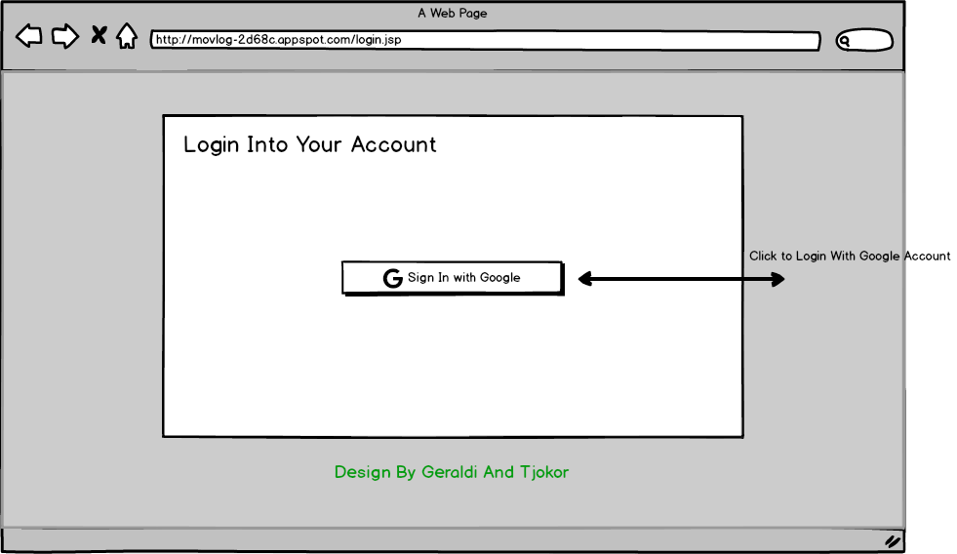

Login Page

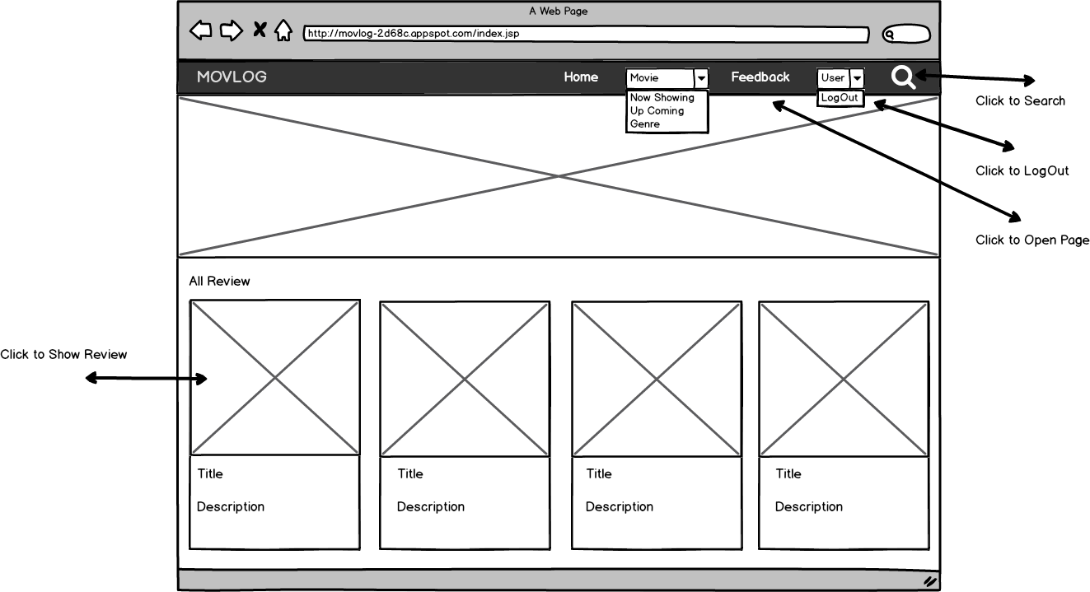

Home Page

\

sssssssssss

**DESIGN INTERFACE**

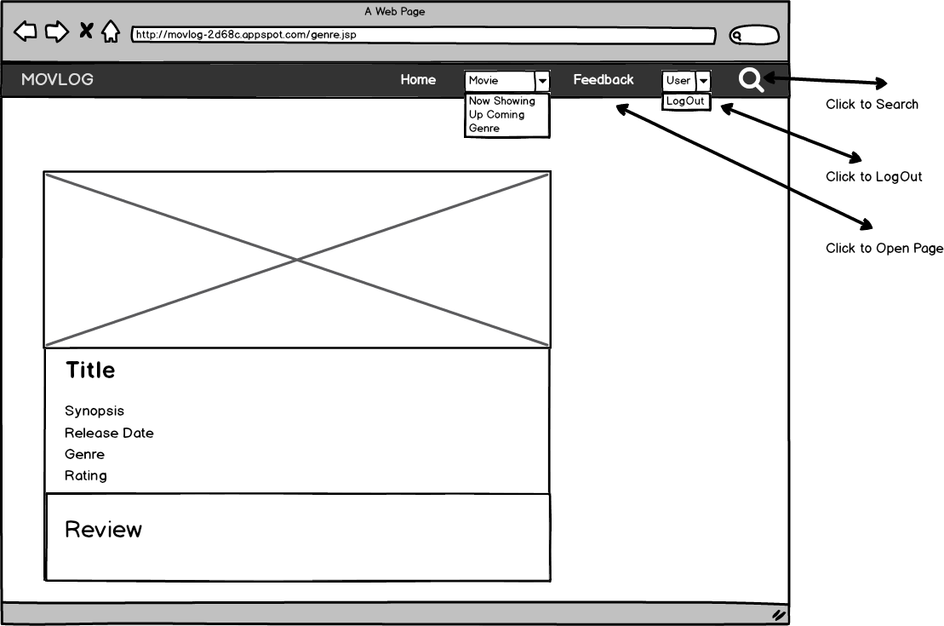

Content Pages

\

sssssssssss

**DESIGN INTERFACE**

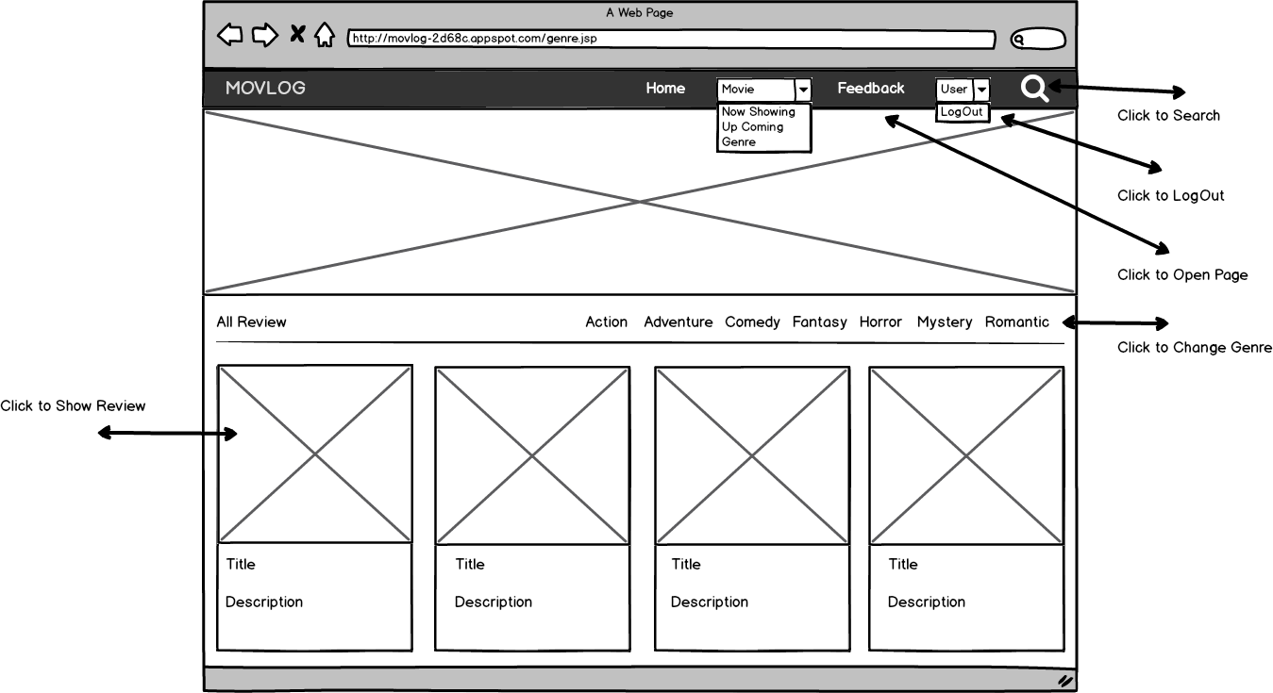

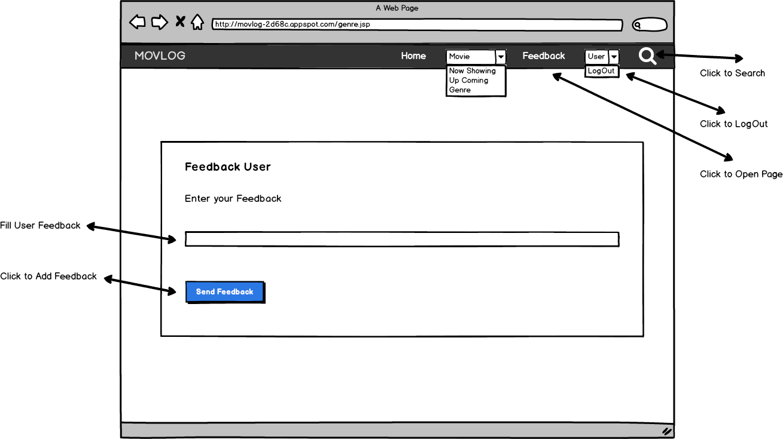

\

sssssssssss

Category Pages

Feedback Page

**DESIGN INTERFACE**

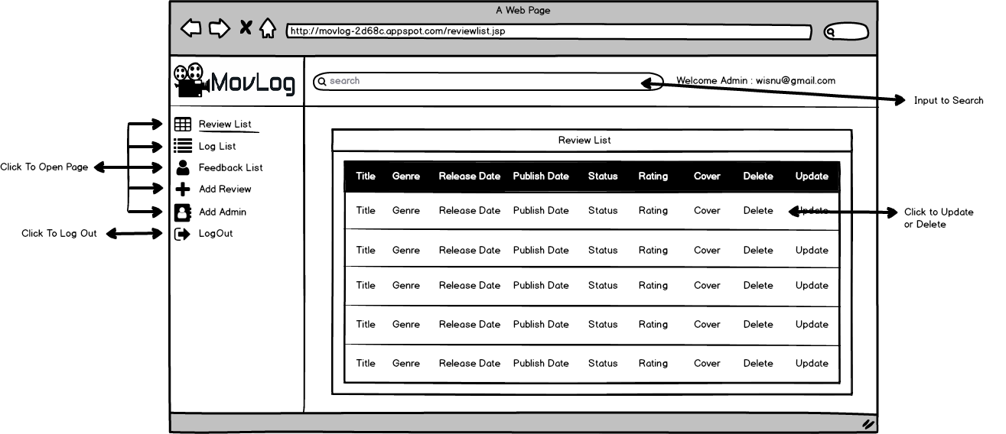

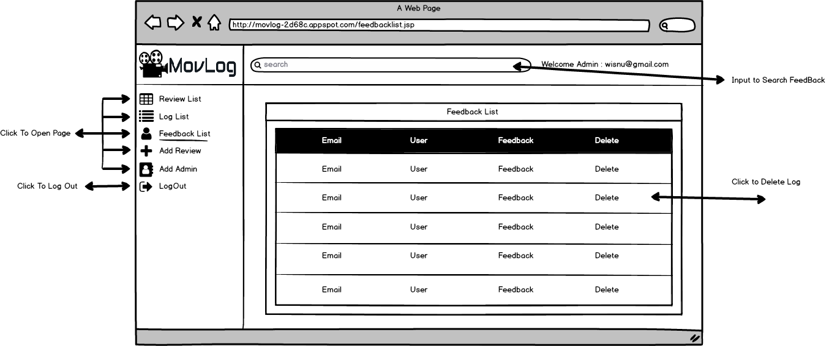

\

Review List Page

Feedback List Page

**DESIGN INTERFACE**

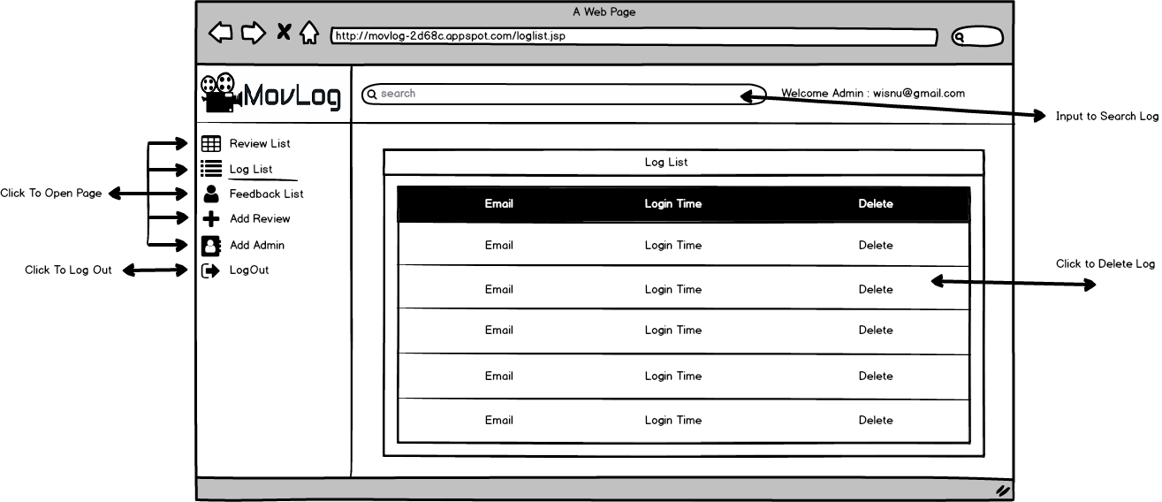

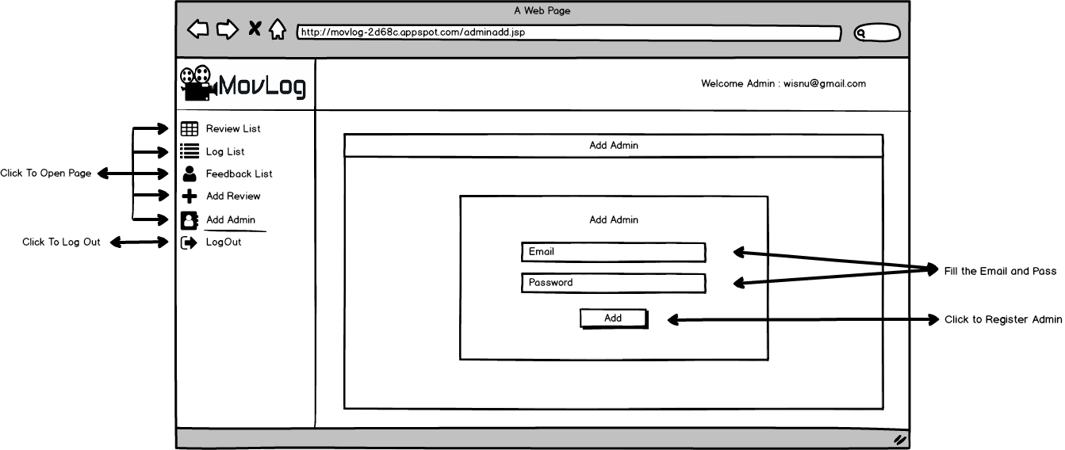

\

sssssssssss

Log List Pages

Add Admin Pages

**DESIGN INTERFACE**

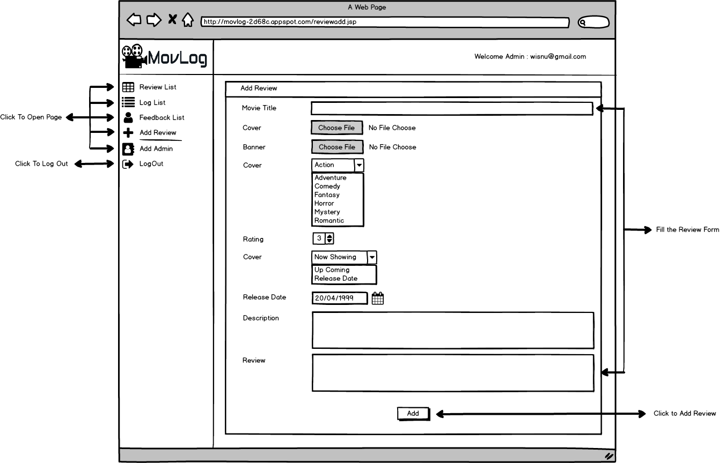

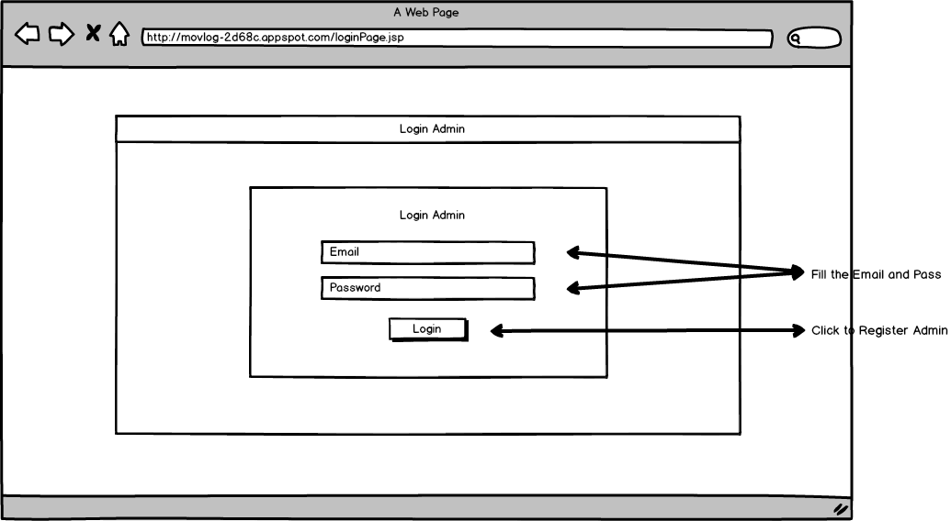

\

sssssssssss

Add Review Page

Login Admin Page

**PREVIEW OF APPS**

Application Preview using Screenshot:

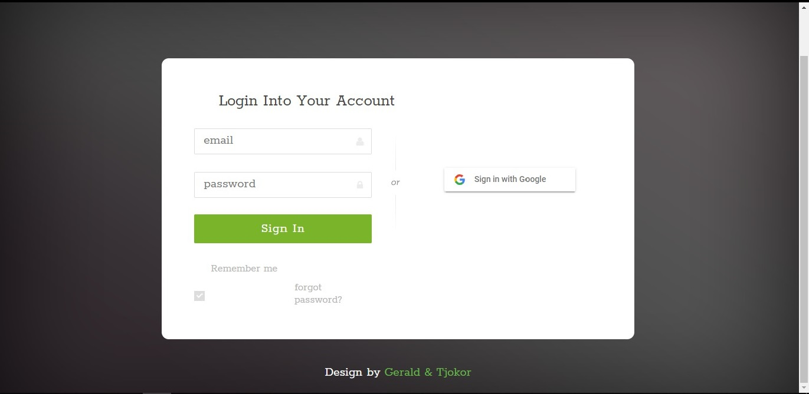

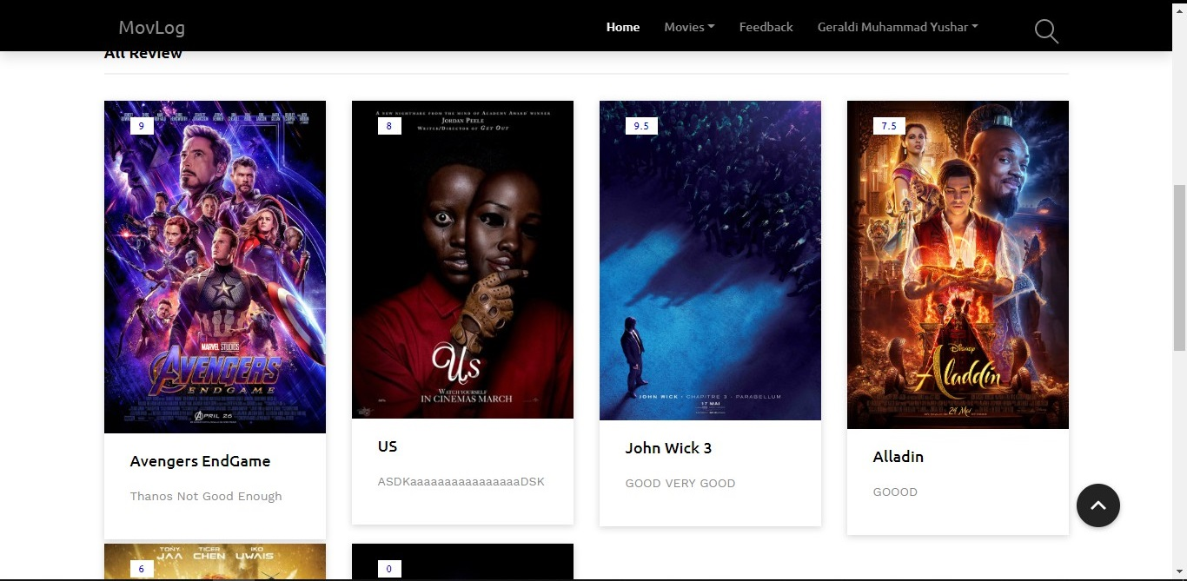

**PREVIEW OF APPS**

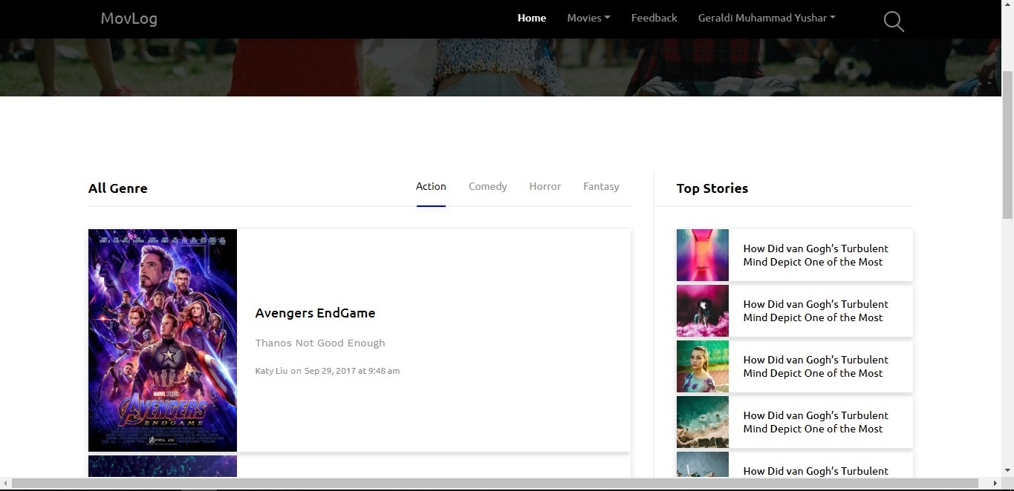

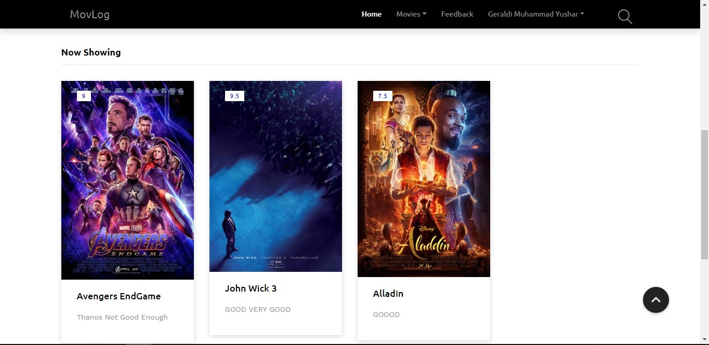

\

sssssssssss

**PREVIEW OF APPS**

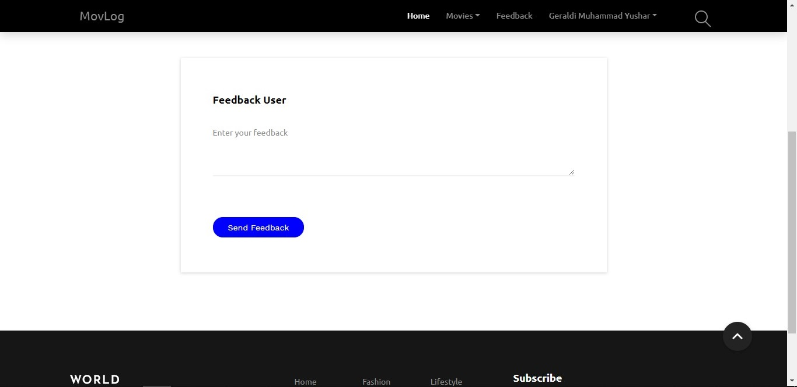

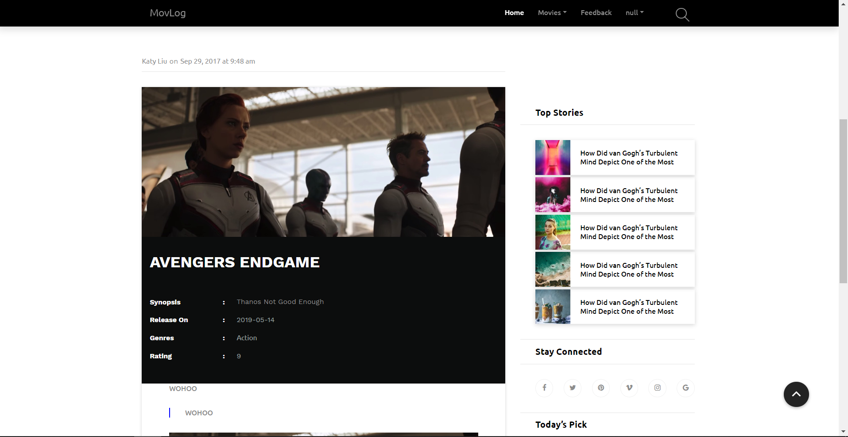

\

sssssssssss

**PREVIEW OF APPS**

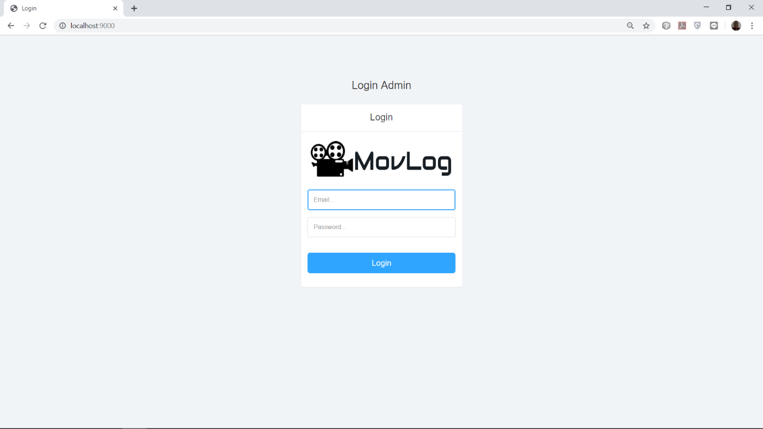

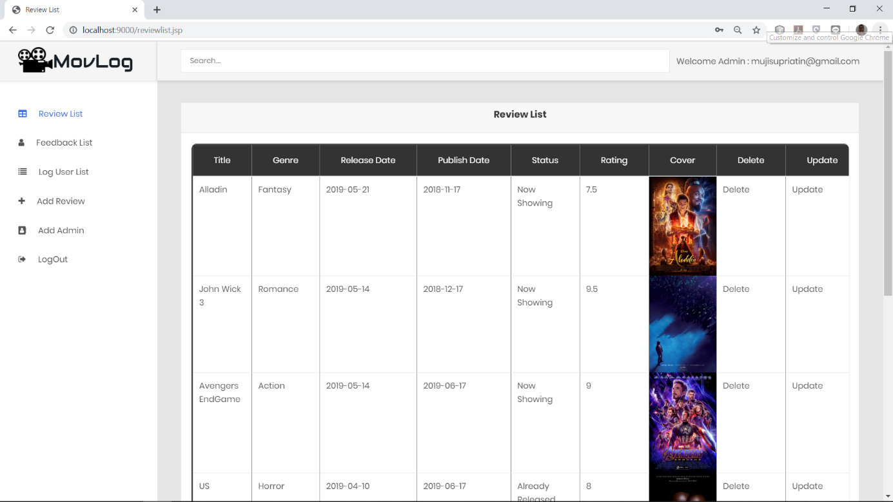

\

sssssssssss

**PREVIEW OF APPS**

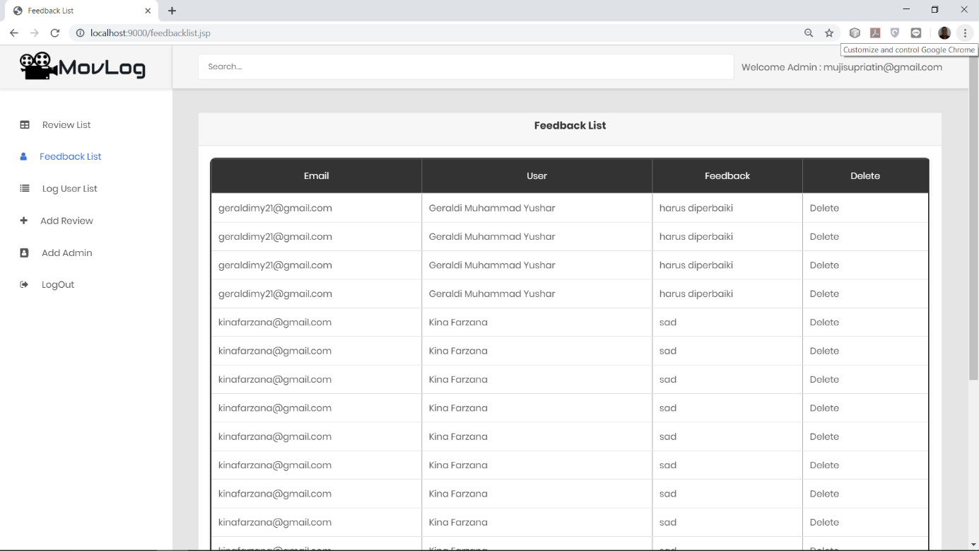

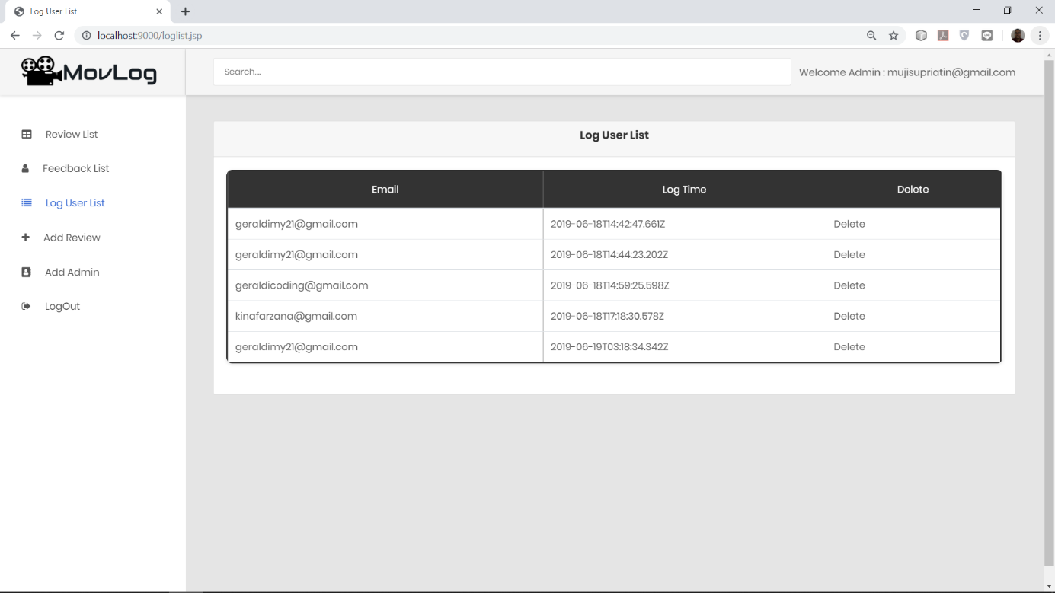

\

sssssssssss

**PREVIEW OF APPS**

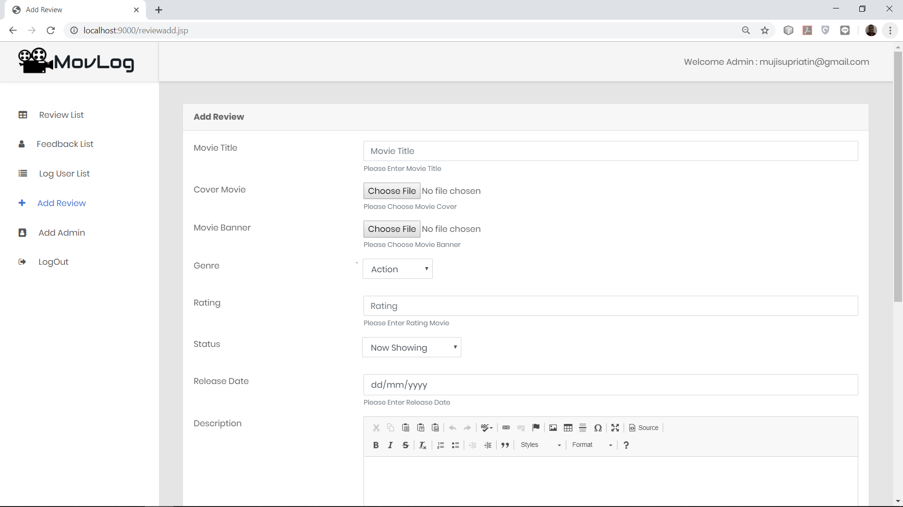

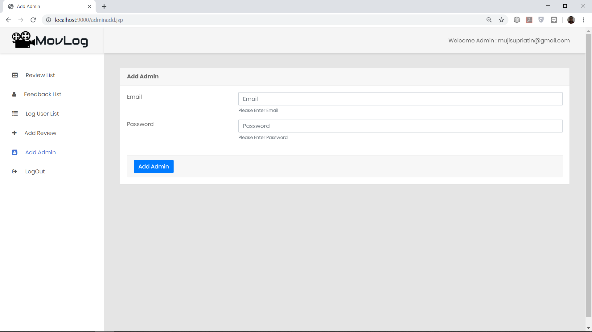

\

sssssssssss

**CONFIGURATION**

**Hardware :** Intel Core I7 1,8GHz, 16GB Ram, Nvidia GeForce GTX 1050

**Operating System :** Windows 10 Pro 64 Bit.

**Software :** Microsoft Office Word 2013, Sublime Text 3, MySQL

|  |  |  |
| --- | --- | --- |
| **S.No** | **File Name** | **Remarks** |
| 1 | css(folder) | Contains CSS for HTML. |
| 2 | js(folder) | Contains JS for HTML. |
| 3 | ckeditor(folder) | Contains CKeditor for HTML. |
| 4 | images(folder) | Contains Images/Video use in this project. |
| 5 | .jsp | Contains website pages and all the function for this project. |